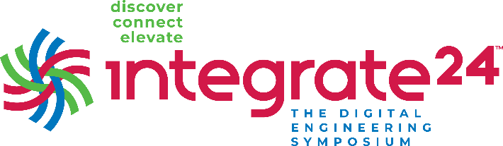

Hi [insert boss’ name],

I’m interested in attending Integrate24 on September 17-19 in Cleveland, Ohio.(full details are [here](https://www.integrate24.net/)) and would like to know if you’d be able to offer the financial support for me to do so.

Vitech’s - Integrate24 event focuses on education and is filled with opportunities for networking and learning. An added feature is that the event is co-located with Zuken Innovation World Americas (ZIW), so there are more than 90 classes/sessions across seven dedicated tracks. And a single fee provides entry into both events. Sessions are for the designers, the makers, the innovators, and the thinkers.

The Expert Bar will allow me to meet one-on-one with Vitech technical staff to answer my questions about [X]. I can meet with partners in the Technology Showcase and learn more about their complementary technologies. The Digital Engineering Hub provides a new perspective on this type of event, with content geared towards the IT departments responsible for deploying and maintaining these systems. And during the 360 session, I’ll be able to ask the management team questions about [X].

This is not your typical user event. Instead, it’s more focused on providing networking opportunities, connecting professionals from multiple industries, and providing practical knowledge to help attendees right away.

Between the content presented in the 99+ classes and sessions, I plan to strengthen my skills in [X], [Y], [Z], and from the research I’ve done into the upcoming event, I think it will help me in attaining these goals:

* Goal #1:
* Goal #2:
* Goal #3:

These are some of the classes/sessions I’d like to attend:

* Class #1:
* Class #2:
* Class #3:

I believe Integrate24 would benefit us by furthering my knowledge and expertise in many areas of MBSE. Connecting with other colleagues and learning about their challenges can give us some insight and inspiration. I’ll submit a post-event report, including an executive summary, major takeaways, tips, and pictures.

I welcome the chance to discuss this opportunity with you in further detail. Let me know if there’s any additional information you need from me to make your decision.

Thanks,   
[Your name]